Solution Architecture
The Solution Architecture defines the structural design of the system and illustrates how different components interact with each other.
4.1 Architectural Overview
The system follows a modular architecture consisting of:
- Data Input Layer
- Processing Layer
- Machine Learning Layer
- Output and Visualization Layer

4.2 Data Input Layer
- Collects motor parameters such as current, voltage, speed, torque, and ambient temperature
- Supports real-time and historical data

4.3 Data Processing Layer
- Handles data cleaning and normalization
- Performs feature extraction
- Prepares data for ML model input

4.4 Machine Learning Layer
- Trains regression-based ML models
- Predicts motor temperature
- Evaluates model performance

4.5 Output and Visualization Layer
- Displays predicted and actual temperature values
- Generates alerts and reports
- Supports decision-making for maintenance
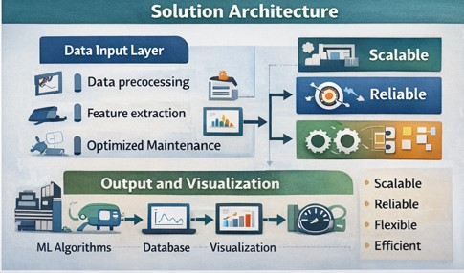

4.6 System Characteristics
- Scalable: Can support multiple motors
- Reliable: Ensures accurate predictions
- Flexible: Can integrate additional parameters
- Efficient: Low latency prediction

Conclusion of Project Design Phase
The Project Design Phase successfully translates the identified problem into a structured, efficient, and scalable solution. By ensuring a strong problem–solution fit, analyzing possible approaches, defining a clear proposed solution, and designing a robust system architecture, the project is well-prepared for the implementation and testing phases.

